**CHAPTER 1: INTRODUCTION**

* 1. Background

With the drastic flourishment of software world, need of application is also augmented in every sector of mankind. So, organized view and storage has been the first concern. Same is the case in educational sector as well. There is inconveniency in processing the educational institute or college information among students, teachers, & managerial staffs visiting individual doorsteps. With the normal non-electronic information flow, there can’t be proper relationships and unity among the students, teachers and managerial staffs. In present scenario, sharing of proper education materials, notes, resources, assignments, etc. without electronic flow is very much difficult and inefficient.

These present status of educational institution led us to point out the idea and develop our project “College Information Management System”. CIMS can engulf all the problems above with the additional features of messages, resources, routines and so on. With the login mechanism and permission granting to each users, system is secured and organized as well. CIMS enables to get records of all faculty members, staffs and students and to give full mobilization to the resources and messages. There is also the provision for routine and subject assignment. Each user has to login and there is separate profile for all. The unnecessary job to occupy whole day for result distribution and suggestions can be easily done with the notifications through our application.

CIMS is a web application developed to nullify the problems of educational institutes and to establish new and fast trend of educational flows for easy and organized view, and overall processing in that institution or college.

* 1. Problem Statement

With our research for the project, we found a web based application, Fedena, which is also multipurpose school management software and student information system. It allows different functionality but still lacks the proper information flow, routine assignment and sharing resources. There are number of problems still present in educational institute which are unrecognized or ignored if recognized. In this information age also, if information can’t be mobilized or managed in electronic fast way, especially in colleges, it directly indicates the lagging phase of education system.

Still lots of ideas and solutions to the problems in the mind of staffs and students, there is no sharing media to uplift the overall academic performance. Processing the ideas only in college time and then setting meeting and only implementing after evaluation is a long, unnecessary and time waste mechanism.

The only solution to all these problems is CIMS.

CIMS not only organized the management sector of colleges but also provides full communication and proper information and idea flow among all college family. Along with it, it can be used from anywhere anytime with complete notifications of updated records.

* 1. Rationale of the project

There is a huge gap between the teachers, managerial staffs and the students in the academic field. This leads to the lack of proper relationship among them and overall low academic performance. This is never the goal of educational institutes or colleges. Similarly, poor information flow among the students, teachers and staffs ultimately reduces the quality of the education. The performance of every college staffs and students will be slow and negative if they can’t communicate with each other in user interface electronic media. Every college still lack these problems. Again, reaching every classes for notifying students and visiting every managerial staffs’ doorstep is time legacy and vigorous way of education system. Making individual mark sheet for all students in small exams like in unit test or internal assignment is difficult, time consuming and neglecting part in academic institution.

As, there are lots of unnoticeable but needed factors in education system, which are still ignored. In this scenario, the need of CIMS can be listed as below:

1. Poor information flow between the students, teachers and managerial staffs ultimately reduces the quality of the education.
2. Collecting information regarding various academic works and notices via visiting every Managerial staffs’ doorstep is a sluggish nature of education system.
3. Sharing of proper education matters, notes assignment through non-electronic media is inconvenient.
4. Non unity among the College Managerial team, the Teachers and the Students can be discarded.
5. Proper solution of the issues regarding students, teachers and staffs need a group discussion with liberty though.
   1. Objectives

With the research of the problems and issues in educational system, side by side major objectives that are considered with principal idea of CIMS are as follows:

1. To establish a smooth informative relationship between the various entities of Colleges
2. To minimize the overheads caused due to inefficiency of various resource sharing between the various authorized college bodies, the Tutor and the students
3. To maintain a proper profile based information of the students and the staffs
4. To create a user-friendly environment of proper flow of information like notices, schedules etc.
5. To create a spirit of unity within the college premises and its various bodies.

# CHAPTER 2: LITERATURE REVIEW

2.1 Microsoft Visual Studio 2013

Microsoft Visual Studio is the default development environment for developing Windows applications, ranging from traditional WinForms to the latest WinRT creations. VS 2013 offers performance analysis for XAML UI Responsiveness among other metrics. VS 2013 also supports Office 365 Cloud Business application development. With rumors swirling that a fully implemented Microsoft Office suite will one day make it to Android and iOS platforms, this technology has tantalizing possibilities for easy Office-centric ALM across a variety of mobile platforms. Web development is another area where VS2013 has made ample improvements. ASP.NET developers will be pleased to discover that they can comfortably mix and match whatever framework they prefer (MVC, Web API, WebForms) in the same project.

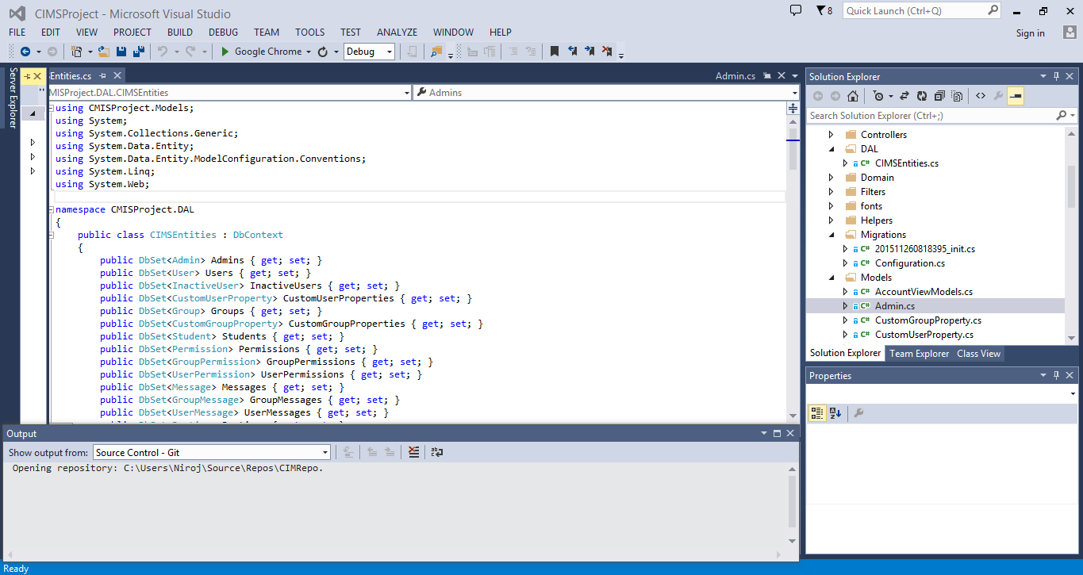

Fig 2.1: Microsoft Visual Studio Professional 2013

It includes a code editor supporting IntelliSense as well as code refactoring. The integrated debugger works both as a source-level debugger and as a machine-level debugger. It supports languages by means of languages services, which allow the code editor and debugger to support nearly any programing language, provided a language specific service exists. Built-in languages include C/C++ (via Visual C++), VB.Net (via Visual Basic.Net), J# and C# (via Visual C#). It also supports XML/XSLT, HTML/XHTML, Java Script and CSS. It allows File System Support, Local IIS Support and FTP Support.

2.2 .Net Framework 4.0

The .Net Framework is the infrastructure for the Microsoft .Net platform, specially designed to make working with the Internet easy. It includes a large library of coded solutions to common programming problems and a virtual machine that manages the execution of programs written specifically for the framework. At the base of the .Net Framework is the Common Language Runtime (CLR).

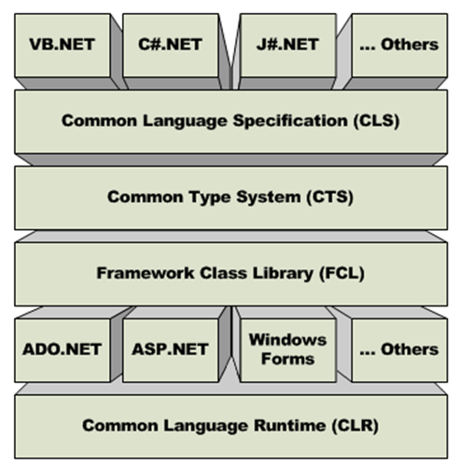

Fig 2.2: .Net Framework

The current track of Microsoft development has three [major verticals for certifications](http://www.c-sharpcorner.com/Blogs/10813/future-of-windows-forms-wpf-and-Asp-Net.aspx); they are:

1. Windows Store Apps
2. Web Applications
3. ALM (Application Lifecycle Management)

Additionally, .Net is found going strong in:

1. **Languages:** Microsoft has spent a lot in two languages [C#](http://www.c-sharpcorner.com/1/144/C-Sharp-language.aspx) and [XAML](http://www.c-sharpcorner.com/1/190/xaml.aspx). No matter if you develop a Windows Phone app, Windows 8 app, ASP.NET web application, a service, or Windows thick clients, you can use these two languages.
2. **WCF:** Either you build large enterprise applications or mobile applications, [Windows Communication Foundation (WCF)](http://www.c-sharpcorner.com/1/192/wcf-with-C-Sharp.aspx) has become an industry standard to build distributed applications.

The following are the new features of .NET Framework 4.0:

1. Improved Application Compatibility and Deployment Support
2. Dynamic Language Runtime
3. Managed Extensibility Framework
4. Parallel Programming framework
5. Improved Security Model
6. Networking Improvements
7. Improved Core ASP.NET Services
8. Improvements in WPF 4
9. Improved Entity Framework (EF)
10. Integration between WCF and WF

2.3 ASP.Net MVC 5

ASP.NET is a server side scripting technology that enables scripts (embedded in web pages) to be executed by an Internet Server. It is a development framework for building web pages and web sites with HTML, CSS, JavaScript and server scripting. ASP.NET has better language support, a large set of user controls, XML-based components, and integrated user authentication. ASP.NET pages have the extension .aspx, and are normally written in VB (Visual Basic) or C# (C sharp). This project is written in C#.

When a browser requests an ASP.NET file, the ASP.NET engine reads the file, compiles and executes the scripts in the file, and returns the result to the browser as plain HTML.

ASP.NET supports three different development models: Web Pages, MVC (Model View Controller), and Web Forms.

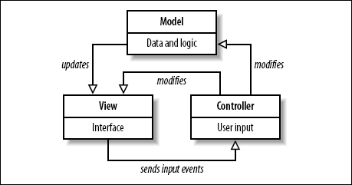

Fig 2.3: MVC model

**The Model** is the part of the application that handles the logic for the application data. Often model objects retrieve data (and store data) from a database.

**The View** is the parts of the application that handles the display of the data. Most often the views are created from the model data.

**The Controller** is the part of the application that handles user interaction.  
Typically controllers read data from a view, control user input, and send input data to the model.

Additional to all above, ASP.Net easily works with ADO.Net using data binding and page formatting features and also supports Bootstrap. Its application run faster and counters large volume of user without performance problems.

2.4 Microsoft Visual C#

Microsoft Visual C# is Microsoft’s implementation of the C# programming language specification included in the Microsoft Visual Studio suite of products. It is based on the ECMA/ISO specification of the C# language, which Microsoft also created. Microsoft Visual C# is a programming environment used to create graphical user interface applications for the Microsoft Windows family for operating systems. It usually ships either by itself or as part of Microsoft Visual Studio. In most contexts, an unqualified reference to C# is taken to mean Visual C#.

Simply, C# (pronounced "C sharp") is a simple, modern, object-oriented, and type-safe programming language. C# combines the high productivity of Rapid Application Development (RAD) languages and the raw power of C++. Visual C# .NET is Microsoft's C# development tool. It includes an interactive development environment, visual designers for building Windows and Web applications, a compiler, and a debugger.

Creating programs in a C# is a snap. The language is powerful and easy to learn, and the Visual Studio IDE does a lot of work for us automatically. We can leave mundane coding tasks to the IDE and focus on what our code should accomplish.

2.5 Microsoft SQL Server

Microsoft SQL Server is a relational model database server produced by Microsoft. Its primary query languages are Transact-SQL, an implementation of the ANSI/ISO standard structured Query Language used by both Microsoft and Sybase. SQL Server is commonly used by business for small to medium-sized databases, but he past five years have seen greater adoption of the product for larger enterprise databases.

The current version of the SQL Server is SQL Server. It aims to make data management self-tuning, self-organizing, and self-maintaining with the development of SQL Server always on technologies, to provide near-zero downtime. It also includes support for structured and semi-structured data, including digital media formats for pictures, audio, video and other multimedia data.

2.6 IIS

Internet Information Service is a set of Internet-based services for servers using Microsoft Windows. It is an extensible web server created by Microsoft for use with Windows NT family. It supports HTTP, HTTPS, FTP, FTPS, SMTP & NNTP. It has been an integral part of the Windows NT family since Windows NT 4.0. It allows Anonymous authentication that we used in our project for extra security.

2.7 JavaScript

JavaScript is a trademark of Sun Microsystems. It was used under license for technology invented and implemented by Netscape Communications and current entities such as Mozilla Foundation.

JavaScript is an object-oriented scripting language used to enable programmatic access to computational objects within a host environment. Although, also used in other applications, it is primarily used in the form of client-side. JavaScript is implemented as part of a web browser, providing enhanced user interfaces and dynamic websites. JavaScript is a dialect of the ECMA Script Standard and is characterized as a dynamic, weakly typed, prototype-based language with first-class functions. JavaScript was influenced by many languages and was designed to look like Java, but to be easier for non-programmers to work with.

The primary use of JavaScript is to write functions that are embedded in or included form HTML pages and interact with the Document Object Model of the page. Some simple examples of this usages are:

1. Opening or popping up a new window with programmatic control over the size, position, and attributes of the new window (e.g. whether the menus, toolbars, etc. are visible).
2. Validation of web form input values to make sure that they will be accepted before they are submitted to the server.
3. Changing images as the mouse cursor moves over them. This effect is often used to draw the user’s attention to important links displayed as graphical elements.

As JavaScript code can run locally in a user’s browser, it can respond to user actions quickly making an application feel more responsive. Furthermore, its code can detect user actions which HTML alone cannot such as individual keystrokes.

2.8 Bootstrap with HTML 5 and CSS 3

Bootstrap is the most popular HTML, CSS, and JavaScript framework for developing responsive, mobile-first web sites. Bootstrap makes use of certain HTML elements and CSS properties that require the use of the HTML5 doctype. Bootstrap is a free front-end framework for faster and easier web development.

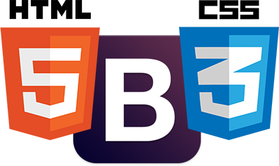

Fig 2.4: Bootstrap with HTML 5 and CSS 3

Bootstrap includes HTML5 and CSS3 based design templates for typography, forms, buttons, tables, navigation, modals, image carousels and many other, as well as optional JavaScript plugins. Bootstrap also gives the ability to easily create responsive designs. Bootstrap is known in the coding world as the front end tool-kit and developmental framework which caters to the developer and includes a seemingly endless resource to build modern web pages and applications. Later because of its attributes, ease and flexibility in designing, it has earned its place as a major framework for designing in HTML 5 and other web development interface. Bootstrap is the best option to choose from that ensures the rapidity of application development.

Advantages of Bootstrap:

1. Easy to use: Anybody with just basic knowledge of HTML and CSS can start using Bootstrap.
2. Responsive features: Bootstrap's responsive CSS adjusts to phones, tablets, and desktops.
3. Mobile-first approach: In Bootstrap 3, mobile-first styles are part of the core framework.
4. Browser compatibility: Bootstrap is compatible with all modern browsers (Chrome, Firefox, Internet Explorer, Safari, and Opera).

2.9 AJAX

AJAX is the abbreviation of Asynchronous JavaScript and XML. It is not a new programming language, but a new way to use existing standards. It is the art of exchanging data with a server, and update parts of a web page without reloading the whole page. It is a group of interrelated web development methods used on the client-side to create interactive web applications. With Ajax, web applications can send data to, and retrieve data from a server asynchronously (in the background) without interfering with the display and behavior of the existing page.

Ajax is a way of developing Web applications that combines:

1. XHTML and CSS standards based presentation
2. Interaction with the page through the DOM
3. Data interchange with XML and XSLT
4. Asynchronous data retrieval with XML HTTP Request
5. JavaScript to tie it all together

The significance of using AJAX in CIMS is that it does not alters the system at the time of user using the functionalities of the system.

2.10 Adobe Photoshop

Adobe Photoshop, or simply Photoshop, is a graphics editing program developed and published by Adobe Systems.  It can edit and compose [raster images](https://en.wikipedia.org/wiki/Raster_image) in multiple layers [and supports different combination of colors and its models](https://en.wikipedia.org/wiki/Color_model) including [RGB](https://en.wikipedia.org/wiki/RGB_color_model), [CMYK](https://en.wikipedia.org/wiki/CMYK_color_model), [Lab color space](https://en.wikipedia.org/wiki/Lab_color_space), [spot color](https://en.wikipedia.org/wiki/Spot_color) and [duotone](https://en.wikipedia.org/wiki/Duotone). Photoshop has vast support for [graphic file formats](https://en.wikipedia.org/wiki/Graphic_file_format) but also uses its own PSD and PSB file formats which support all the aforementioned features. In addition to raster graphics, it has limited abilities to edit or render text, [vector graphics](https://en.wikipedia.org/wiki/Vector_graphics) (especially through [clipping path](https://en.wikipedia.org/wiki/Clipping_path)), [3D graphics](https://en.wikipedia.org/wiki/3D_graphics) and [video](https://en.wikipedia.org/wiki/Video).

It is a popular program for creating and modifying images for the web. Here, we designed the basic outlook of the web pages.

2.11 Microsoft Visio 2013

Microsoft Visio is a [diagramming](https://en.wikipedia.org/wiki/Diagramming_software) and [vector graphics](https://en.wikipedia.org/wiki/Vector_graphics) application and is part of the [Microsoft Office](https://en.wikipedia.org/wiki/Microsoft_Office) Microsoft made Visio 2013 for Windows available in two editions: Standard and Professional. The Standard and Professional editions share the same interface.

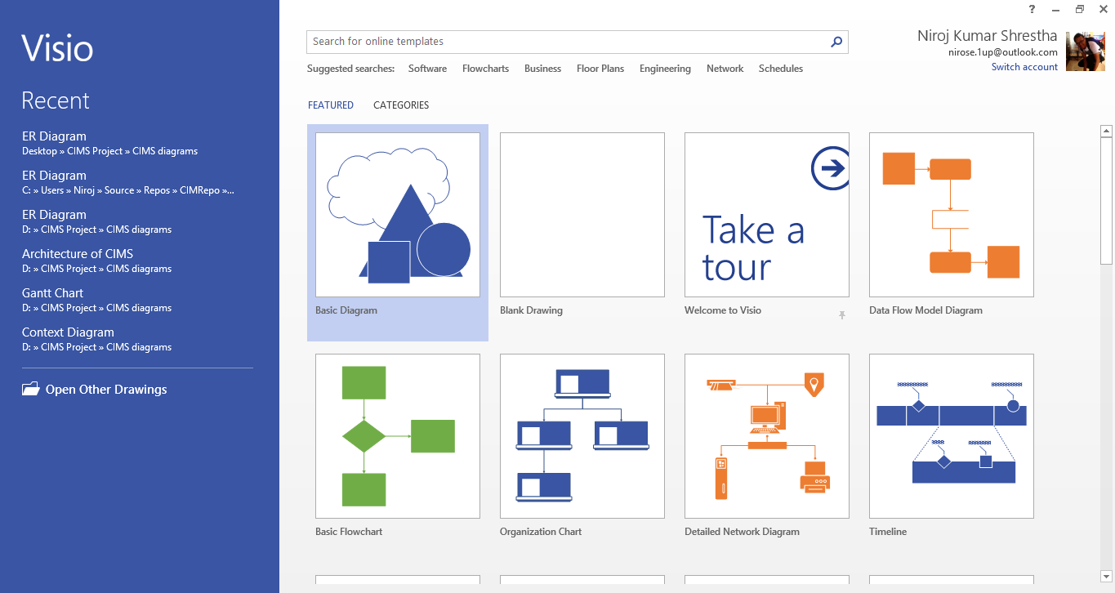

Fig 2.5: Microsoft Visio Professional 2013

We used this application to draw all system design diagrams i.e. ER diagram, Context diagram, Data flow diagrams, use-case diagram, flowchart and architecture of the system.

2.12 RAD

Rapid application development model stages

There are several stages within a rapid application development model. Combined, these stages take the project team through the complete application lifecycle, from idea conception all the way through to production and subsequent iterations.

It’s important to note that [rapid application development](https://www.mendix.com/rapid-application-development/) is an iterative process which focuses on the frequent release and update of apps. The cycle repeats the following steps:

**Design** – Capture, refine and prioritize user stories; estimate, plan and monitor sprints and releases.

**Build** – Use visual models, pre-built components, and business logic workflows to rapidly develop applications in a common language understood by business and IT.

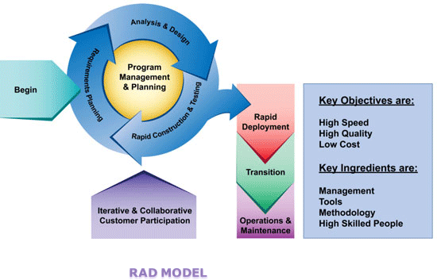

Fig 2.6: RAD Model

**Deploy** – Provision and manage apps in the cloud, including one-click deployment; manage test, acceptance and production environments.

**Manage** – Control all applications from a single dashboard, ensuring availability, security, performance and scalability.

**Iterate** – Gather feedback, including end user input, and use in the next cycle of design-develop-deploy-iterate.

**Collaborate** – Enable closed feedback loops within the rapid application development model so that all stakeholders can communicate and collaborate.

The right [rapid application development software](https://www.mendix.com/rapid-application-development-software/) enables speed and collaboration across the full application lifecycle. The result is the faster release of higher quality applications.

CIMS is designed using this software development approach.

# CHAPTER 3: SYSTEM DEVELOPMENT CONCEPT

3.1 Objective Definition

This chapter encloses the needs of the development of the project. The objects can simply be divided into two parts as following:

* Course Objectives
* Specific Objectives

3.1.1 Course Objectives

This objective fulfills the requirement of the syllabus of the Bachelor in Computer Engineering for final year II semester. The syllabus objectives as per the University rules are listed as following:

1. To plan a complete computer programming project work.
2. To perform the project work under the supervision of Instructor.
3. To perform the written report and give the oral presentation.

3.1.2 Specific Objectives

The objectives of the project are listed below:

1. Flowing proper information among the students, teachers and staffs.
2. Creating login environment for the security of the system and for privacy
3. Letting different users to mobilize the resources and assigning the subjects and routines as per group or user.
4. Letting the entire user to edit their profile with privacy.
5. Developing interface for publishing the result and showing mark sheet with rank.

3.2 Task and Activities

System Development Life Cycle is the process of developing, implementing, and retiring information systems through a multistep process from initiation, analysis, design, implementation, and maintenance to disposal. It helps in establishing a system project plan, because it gives an overall list of processes and sub-processes required for developing a system, which means that it is a combination of various activities.

SDLC includes the various steps towards the development of any system and it has various steps from problem definition to integrating and testing. Similarly, this project also passed through the systematic development life cycle with the concept of software engineering as its backbone, which can be summarized in the following steps:

3.2.1 Development and Phase Definition

Software development is carried out systematically in various phases and the phases are broadly categorized into system planning, analysis, design and implementation. Every phase has its own significance so that these steps have to be carried out in a proper way to get the good outcome and these steps are thoroughly followed during the software development process.

3.2.2 Problem Definition

Problem definition phase is the first in the system development. The concept of the project was developed after the identification of the problem. For the purpose of problem definition various people were visited and interacted with them to know the existing problem and desired solution. The information collected at this phase was the base for the tools collection.

3.2.3 System Analysis

This phase is the identification of various tasks and activities that has to be performed. It is process of developing a detailed analysis of the problem so that the developers can better understand the problem. During this phase, the system to be developed was analyzed in the scientific way for the betterment of the system development. Also various tools to be used was considered in the analysis phase. This step helps to better understand the scope, feasibility and the requirement of the system.

Its steps can be summarized as the following;

1. Understanding the problem:

This is similar to the problem definition but this is detail study of the problem so the problem can be understood in a proper and depth way.

1. Feasibility analysis:

This step deals with the various types of the feasibilities that are needed to be considered during the system development. Mainly there are the different types of feasibility that are needed to be considered and they are:

* Technical Feasibility
* Economic Feasibility
* Operational Feasibility
* Schedule Feasibility
* Legal Feasibility
* Strategy Feasibility

1. Establishing the System Requirements:

This includes the description of the requirement of the users and the groups to whom the product has been targeted.

3.2.4 System Design

After finishing the system analysis, we did the conceptual design of the system through different diagrams such as Use-Case diagrams, Data Flow Diagrams (DFDs), ER diagram and other architecture. It is the creation of the framework that shows developers how to convert the system requirements into a workable, operational system by exploring different design and identifying the best design for the project. It is seen in the following 2 steps:

1. Logical Design:

It identifies the records and relationships to be handled by a system. It focuses on the logic or the reasoning behind the system by breaking down into subsystems and the relationship among them.

1. Physical Design:

It addresses the physical aspect of the system i.e., input and output devices, hardware configuration of memory networks and so on. It also defines data structure, access and file organizations.

3.2.5 System Development Coding

Once the design process has been accomplished, the system development phase was started that has the coding phase along with the coding and testing. Coding is the phase where the pure coding of the project was done according to the part that was distinguished in the design process.

3.2.6 Integrating and Testing

This phase runs parallel to the coding process where the code that has been developed is tested and the new codes are always integrated to get the system requirement. The testing runs parallel to the coding process so that this is considered as the integrated process.

3.2.7 Architecture

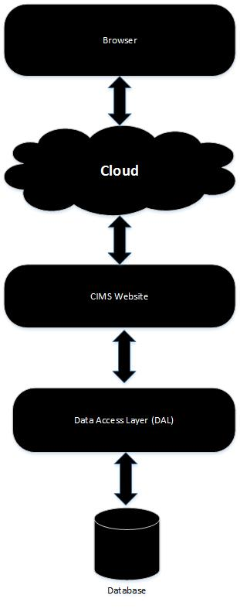

Fig 3.1: Architecture of CIMS

3.3 Refining the System Needs

Once the specified steps of the software engineering have been carried out in an orderly process then, the refinement in the system development can be obtained. This helps in the decision making process for the designers such as us who are still in the learning phase so that the refinement of the project can be done.

In our case, as the system to be designed requires the fine use of the database as well as decision making methods should be incorporated to generate the report. User authentication has been assigned which allows the user of the system to validate the password before entering own profile and into the system as per the permissions granted.

3.4 Conclusion

The development of the system either can be commercially used in the different organizations for the better improvement of the manual dependent and time-consuming work or can be used as the fulfillment of the academic purpose. To accomplish both the task, we need to go thoroughly through the systematic and proper software development phase. All the development process task should be considered while designing the system.

# CHAPTER 4: FEASIBILITY STUDY AND REQUIREMENT ANALYSIS

This chapter includes brief description of the design processes that has been incorporated during the development of the system. The feasibility study and the requirement specifications are set towards the various designs that are compatible with requirements which have been studied by us. The requirement must be focused out from the end user who is the main source of the requirement.

4.1 Feasibility Study

Any project that has to be developed must be feasible under certain constraints within the given resources. A feasibility studies main goal is to assess the economic viability of the proposed system or not.

‘CIMS’ is a feasible system that equally considers economic, technical, and behavioral factors. Since, the students, the teachers and the managerial staffs should be notified with some urgent and important notice or events, or should mobilize the resources with each other in individual or group basis, this system gives any time access to users anywhere wherever there is access to internet. To talk about the technical overview of the ‘CIMS’, it is technically managed and can be handled with less technical knowledge.

4.1.1 Cost/Benefit Analysis:

This is another important step and that needs to be considered for the reason that whether the system that has been developed has the benefit upon the cost in the existing system or not, so that, the betterment in the implementation in the new designed system can be shown.

Since this project doesn’t require any special type of hardware to be installed so that the cost won’t go much higher than the cost of the computers and the cost of the development charge so this surely has a cost benefit. This system requires one-time investment, which may cost much but later this system only needs the updating annually. It also minimizes the cost required for the staffs as less number of staff will be enough in the college.

4.2 Requirement Analysis

This is the main thing that needs to be considered for the system development process. Without the system requirement specification, the system development is not feasible. The requirement analyses have been done by case study of the existing system of the cooperative and questionnaire of different people of educational institutes and colleges.

4.3 Requirement Attribute

4.3.1 Client:

The system is targeted to any colleges and educational institutes.

4.3.2 Target Version:

This is intended to implement the management of the college information and also to allow proper flow of information among the users. Hence, it will be upgraded according to the colleges and educational institutes requirements.

4.4 Requirements

4.4.1 Usability

This system has the GUI interface that gives the access to the system through the web and is easier for the user to learn since the complexity can be reduced by modern tools of the OOP. This requires the user who can just operate a computer even without extra knowledge.

4.4.2 Reliability

The software is the prototype for the requirement and it cannot fulfill the requirements that aren’t dealt with but can be further extended according to the college process and college family requirement.

4.4.3 Performance

The performance of the system is based on the bandwidth of the internet. Higher the bandwidth, better is the performance.

4.4.4 Supportability

Since the entire OOP is done with ASP.NET MVC 5 technology which is taking the global market and as is web application, it is reliable platform to use in any environment.

4.4.5 Scalability

The weight of the requirements won’t affect the performance.

4.4.6 Extensibility

It can be further enhanced to solve the problems that can occur or the problems that has not been identified currently.

4.5 Interfaces

This section defines the interfaces that must be supported by the application. For simplicity, the interface requirements have been categorized into three sections as follows:

4.5.1 User Interfaces:

User interfaces will be implemented as GUI. A set of customizable graphical components, whose similar look and feel emphasizes the system consistency. The User Interface for desktop and distributed applications must assure the convenience to its users.

4.5.2 Software Interfaces:

The system requires drivers for communicating with the adopted database.

4.5.3 Communications Interface:

The software should be distributed in nature capable of handling distributed databases and services. Hence, local area network and remote serial devices are required.

4.6 Conclusion

The project always needs to be finished within the given time constraints and the requirements that are developed and considered during the system development process need to be fulfilled. The planning that has been done before the start of the system development with the requirement should be kept into consideration during the development cycle.

# CHAPTER 5: SYSTEM PLANNING AND DESIGN

This section is the brief description of the design processes that have been incorporated during the development of the system. The term design describes the final system and the process by which it is developed. It refers to the technical specifications that will be applied in implementing the candidate system. It also includes the construction of programs and program testing.

5.1 Schedule Planning

Any project that has to be developed is done under certain constraints in a fixed period and the schedule that had been developed during the system development. The following is the Gantt chart with the full timeline of our project:

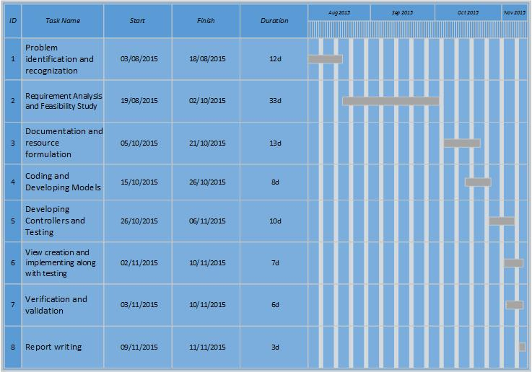

Fig 5.1: Gantt Chart of CIMS

5.2 System Design

System design is a solution It provides the understanding and procedural details necessary for implementing the system recommended in the feasibility study. The emphasis is made on translating the performance requirements into design specification. The design goes through logical and physical stages of development. Logical design reviews the current physical system’ prepares input and output specification’ makes edit security and control specification’ details the implementation plan; and prepares a logical design walkthrough. The physical design maps out the details of the physical system, plans the system implementation, devises a test, implements the plan, and specifies any hardware and software.

5.2.1 Application Environment Establishment

The development of the new system always requires the establishment of the environment where the system has an efficient working condition. This step always takes the operating system into considerations as well as the software package that are used for the software development process. Since ASP.NET is used as the main programming tools, which is platform independent so there is no specific operating system for running the program but following can be recommended for the program.

* Windows all versions with .Net 4.0 framework for server
* Any operating systems as client

5.2.2 Application Design

This is the design of the input and output sections, various process involved and the interfaces that are required for the interaction of the program with the user.

5.2.2.1 Input Design

Input design is and end-user interface that has to be analyzed very consciously, while designing a system. It is important in case of data consistency and data integrity. We have to design input screens and layout in such a way that end-user can enter data and information easily and in limited time for efficiency.

5.2.2.2 Output Design

Output design should be presented in a way that is easy to understand and interpret. Format consistency is an attribute of ‘user-friendly’ output.

5.2.2.3 Process Design

Process models show the overall process and the processes that are supported by the system. Data flow models may be used to show the processes and the flow of information form one process to another. The figures that show the process in our project are shown in the Data Flow Diagram that incorporates the process along with it. DFD graphically illustrates movement of the data between external entities and the process and data stores within a system.

* + - * 1. DFD

A Data Flow Diagram (DFD) is a diagrammatic representation of the information flows within a system, showing:

* How information enters and leaves the system.
* What changes the information.
* Where information is stored.

DFDs are used not only in structured system analysis and design, but also as a general process modeling tool. Having a DFD will make the end users able to visualize the operation of the system, they will see a better perspective what the system will accomplish and how the whole project will be implemented.

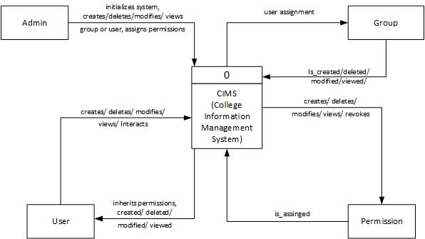

Fig 5.2: Context Diagram

The context-level or level-0 data flow diagram shows the interaction between the system and external agents which act as data sources and data sinks. On the context diagram the system’s interactions with the outside world are modeled purely in terms of data flows across the system boundary. The context diagram shows the entire system as a single process. It’s boundaries by highlighting its sources its sources and destinations. Documenting the system’s boundaries by drawing a context diagram helps the analyst, helps the analyst, the user, and the responsible managers visualize alternative high-level logical system designs.

The Level 1 DFD of the project CMIS are as follows:

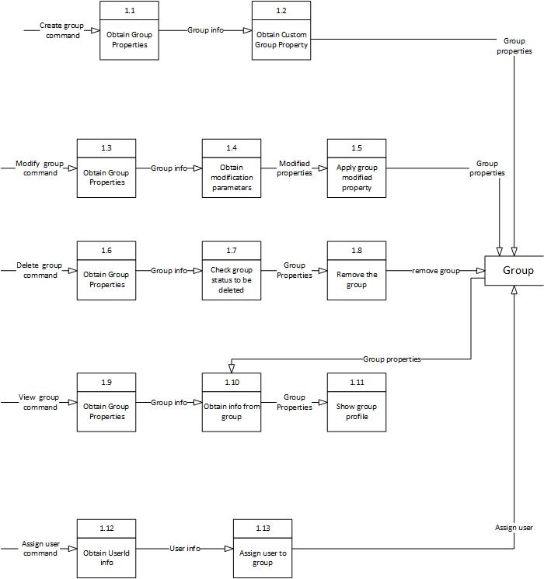

Fig 5.3: Group 1-Level DFD diagram

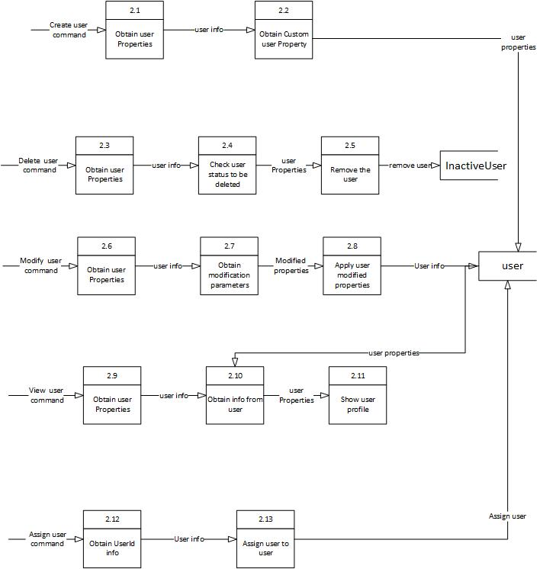

Fig 5.4: User 1-Level DFD diagram

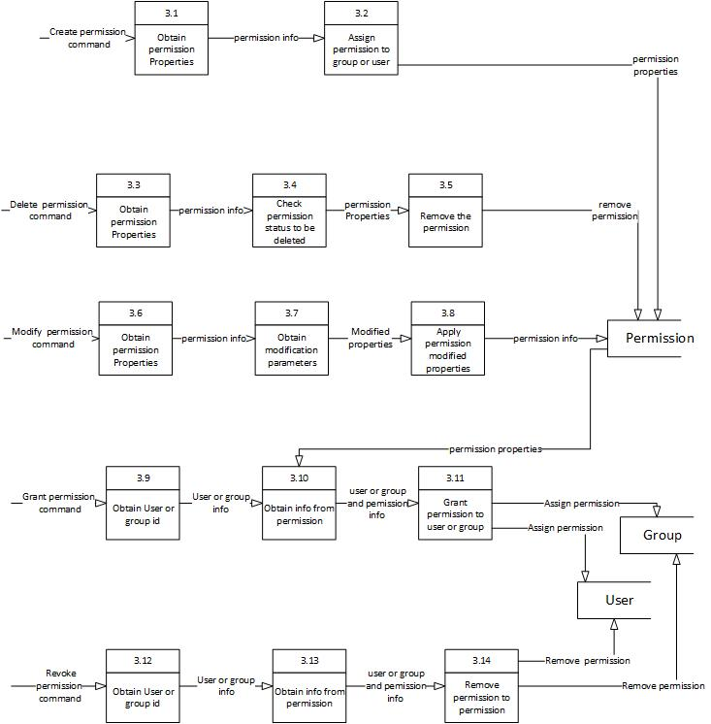

Fig 5.5: Permission 1-Level DFD diagram

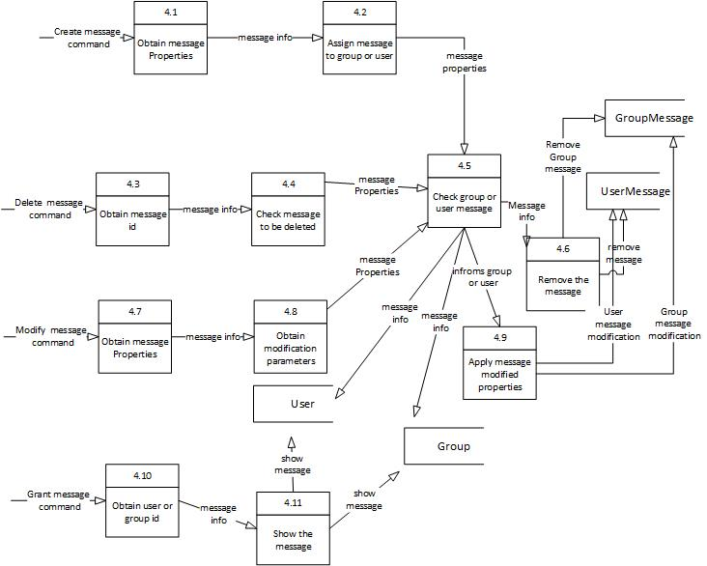

Fig 5.6: Message 1-Level DFD diagram

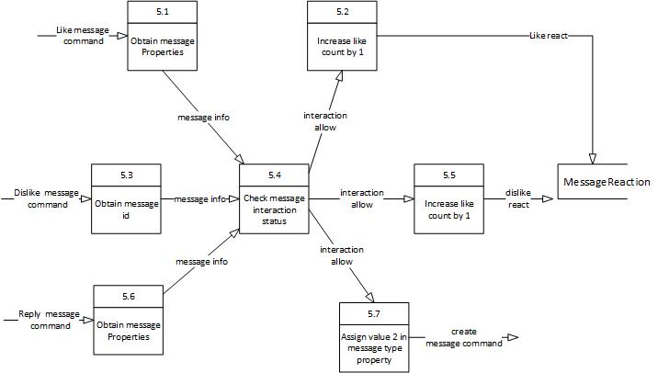

Fig 5.7: Message Interaction 1-Level DFD diagram

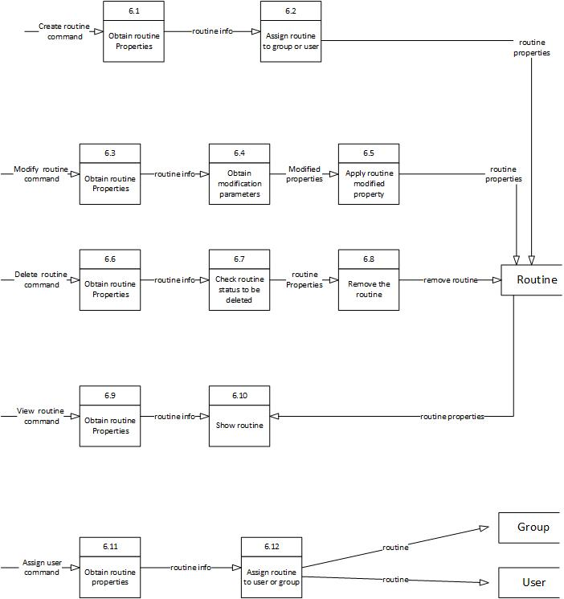

Fig 5.8: Routine 1-Level DFD diagram

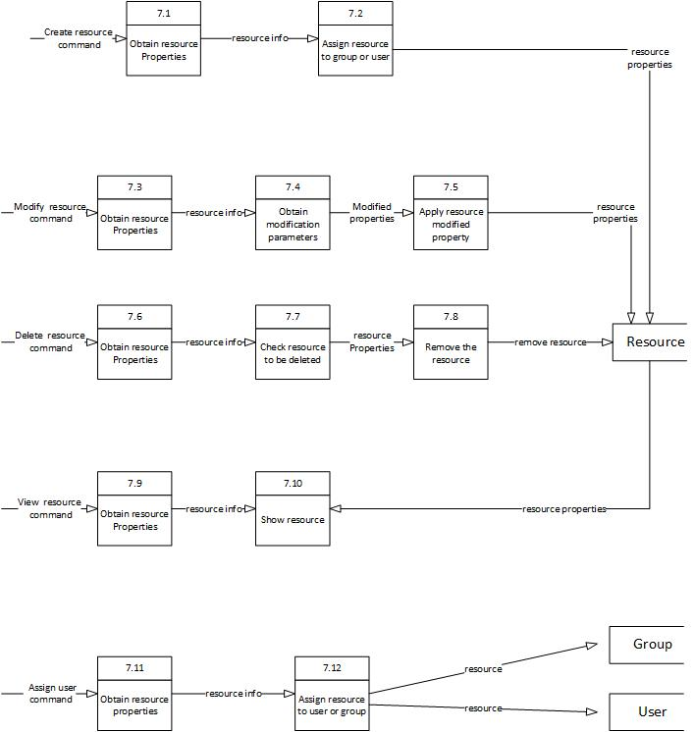

Fig 5.9: Resource 1-Level DFD diagram

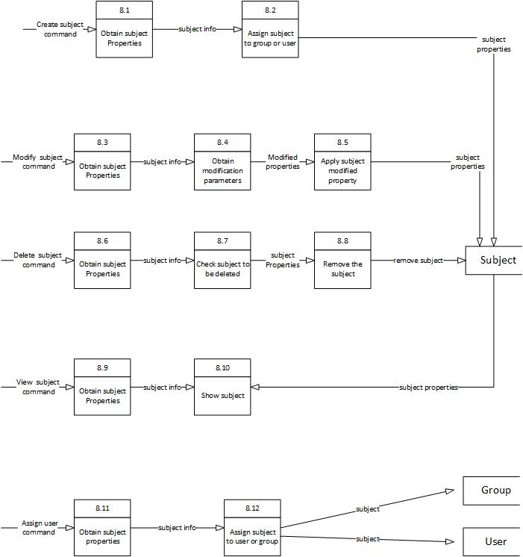

Fig 5.10: Subject 1-Level DFD diagram

* + - * 1. Flow Chart

A flow chart is a graphical or symbolic representation of a process. Each step in the process is represented by a different symbol and contains a short description of the process step. The flow chart symbols are linked together with arrows showing the process flow direction.

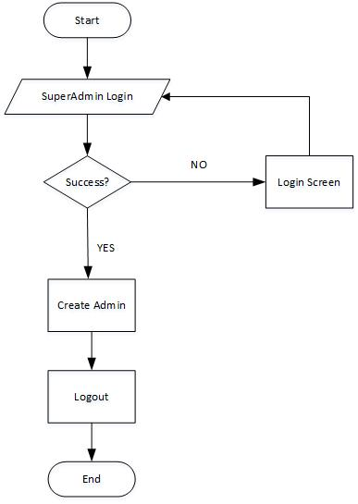

Fig 5.11: Flowchart-1 (Super Admin)

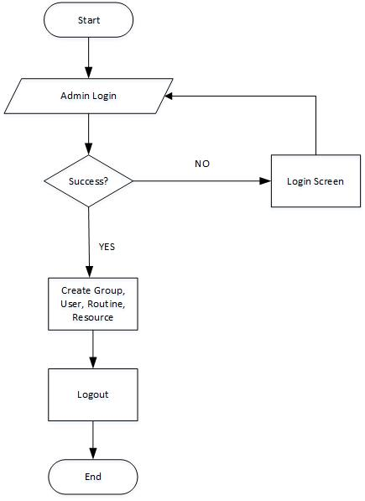

Fig 5.12: Flowchart-2 (Admin)

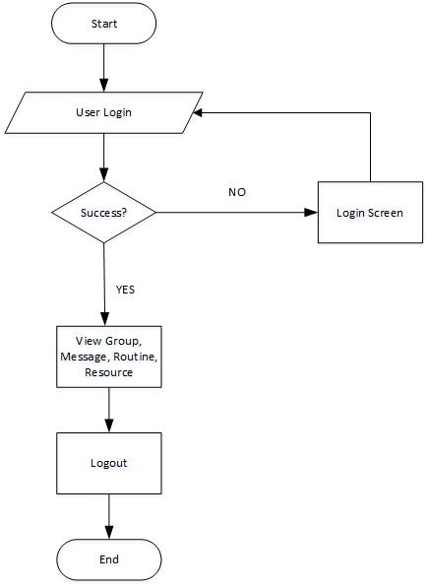

Fig 5.13: Flowchart-3 (User)

* + - * 1. ER Diagram

An entity-relationship (ER) diagram is a specialized graphic that illustrates the interrelationships between entities in a database. ER diagrams often use symbols to represent three different types of information. Boxes are commonly used to represent entities. Diamonds are normally used to represent relationships and ovals are used to represent attributes.

ER diagram is an abstract and conceptual representation of data. Entry-relationship modeling is a database modeling method, used to produce a type of conceptual schema or semantic data model of a system, often a relational database, and its requirements in a top-down fashion. Diagrams created by this process are called entity-relationship diagrams, ER diagrams, or ERDs. The building blocks of ER Diagram are entity, attribute and relationships.